**Title: -**

**Programming language**

By:

|  |  |  |  |
| --- | --- | --- | --- |
| 1 | Hassan zaki Hassan geera | Hasan195326@feng.bu.edu.eg | 295 |

**Approved by:**

|  |  |
| --- | --- |
| Examiners committee | Signature |
| Dr. ahmed bayoumi |  |
| Dr . shady elmashad |  |
| Dr. abdelhamed attaby |  |

The programming language is the everything in life today and in the future

everything around us is programming the smart phone the home equipment

programming make life easy and do the things that the human do by press button

we are surrounded of programming every game every social media site or

application all of this things made by programming and in the future the programming

will make robots to do the jobs that the human should do and every language in

programming do specific thing:

c: make games

html and css and php make sites on the internet

and so

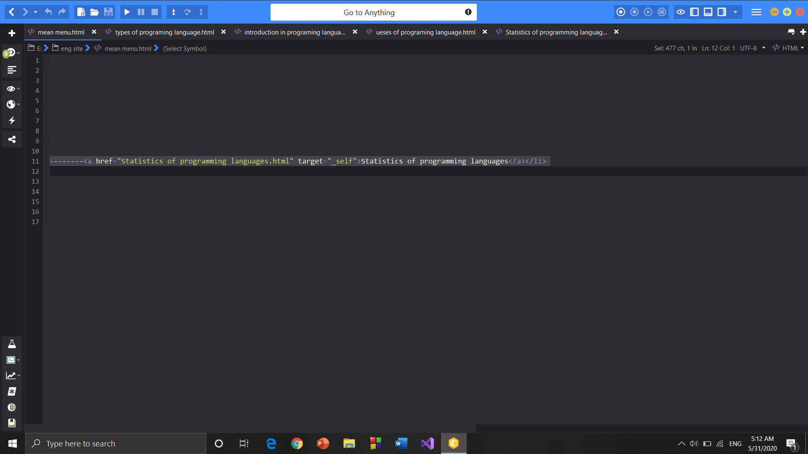**screen shots from the code and site:**

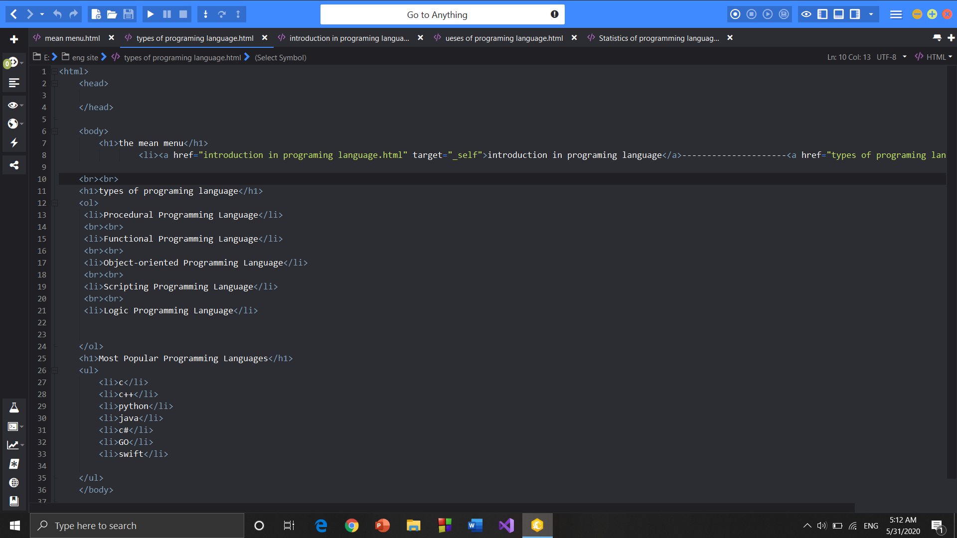

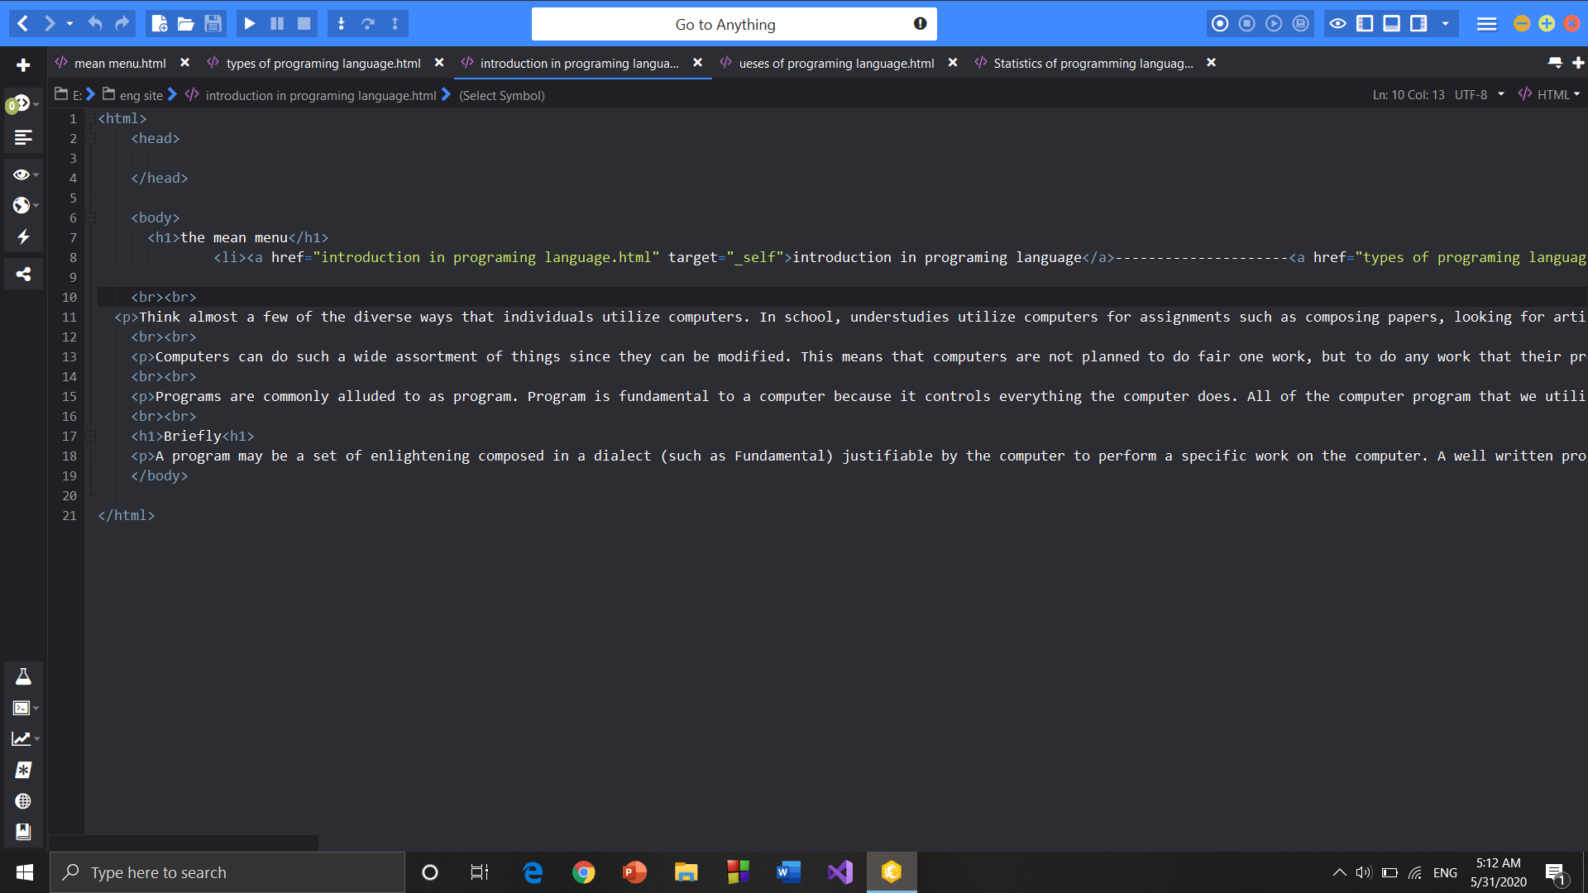

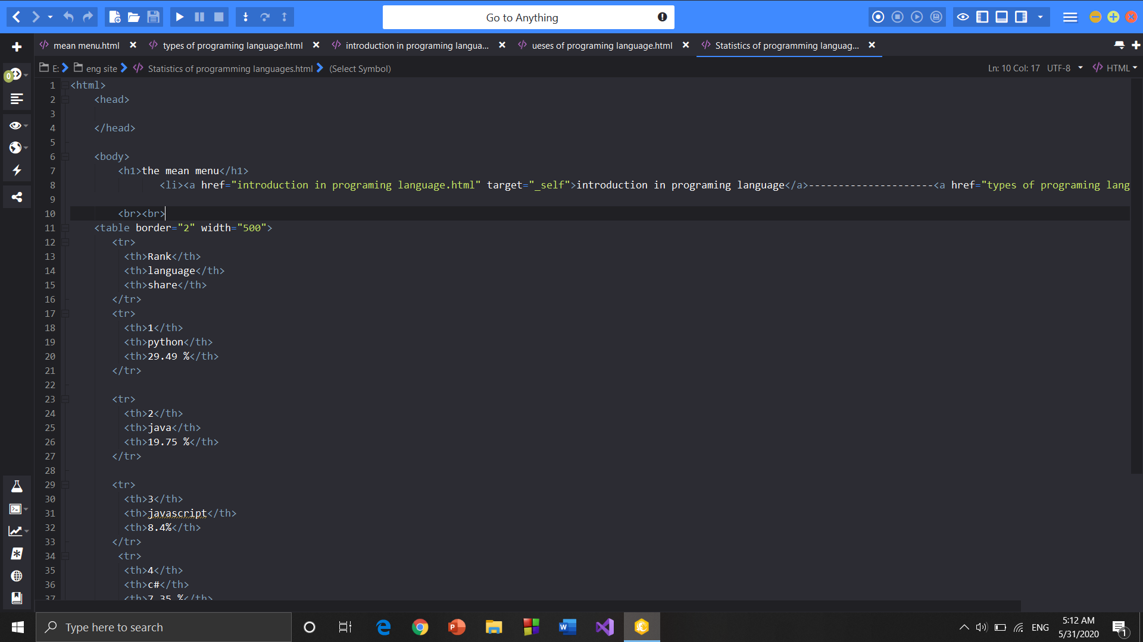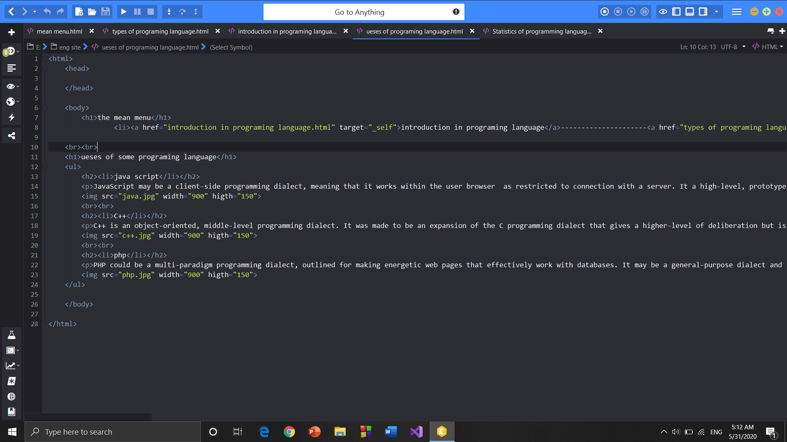

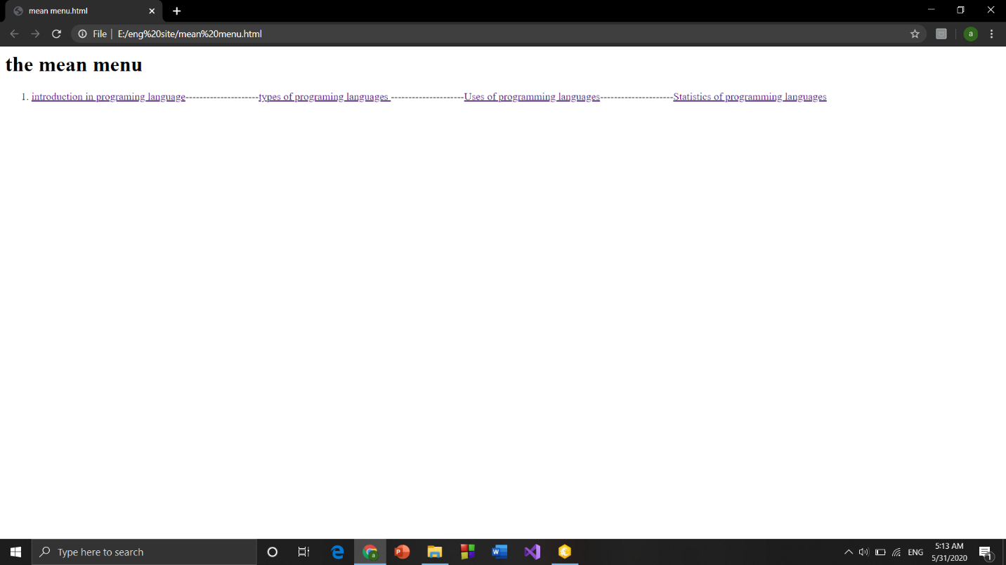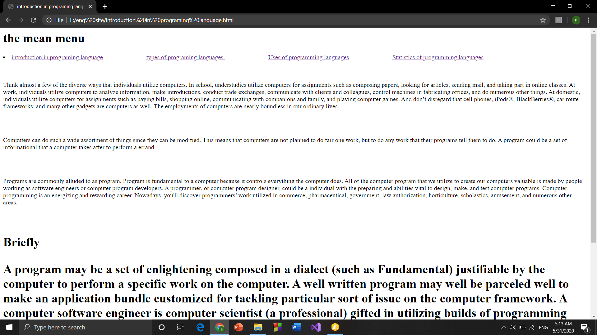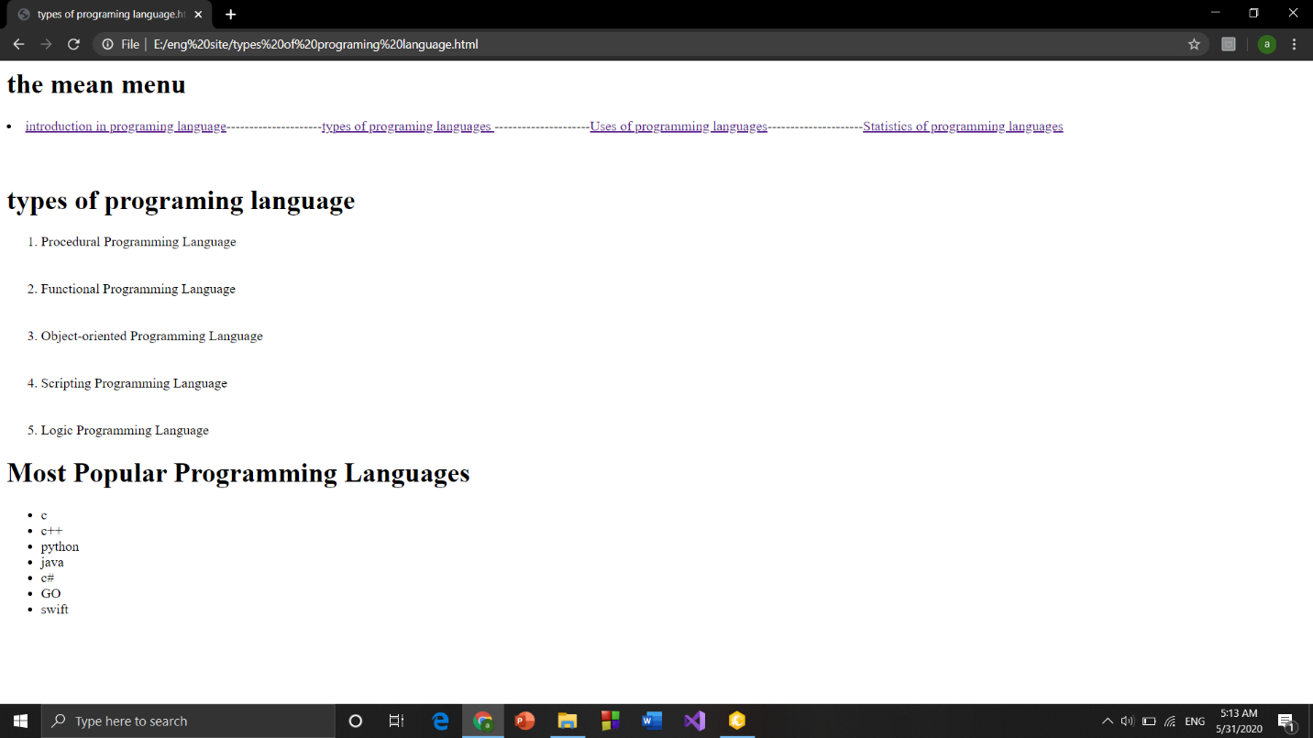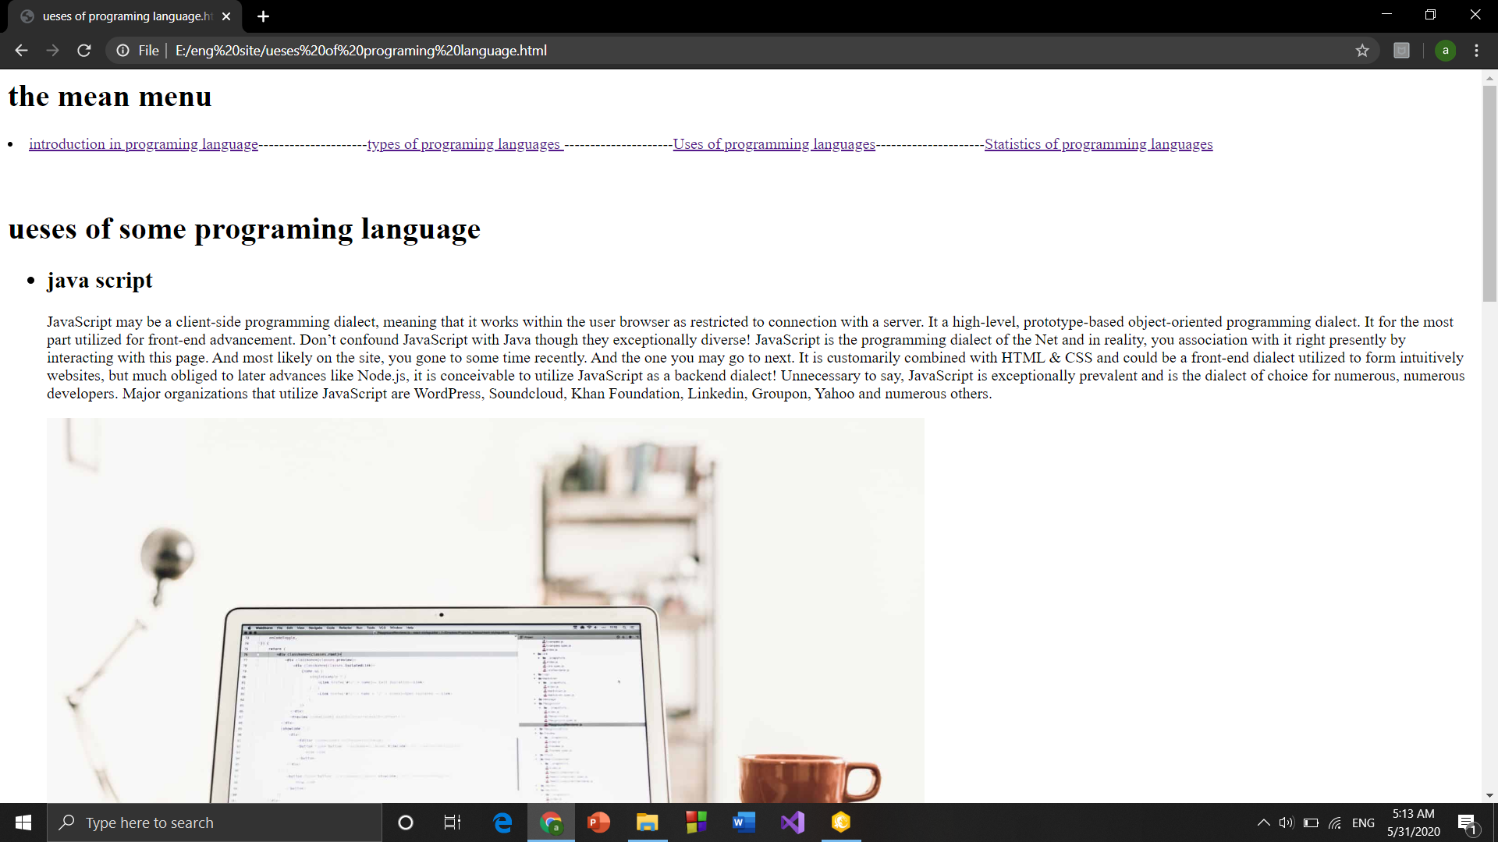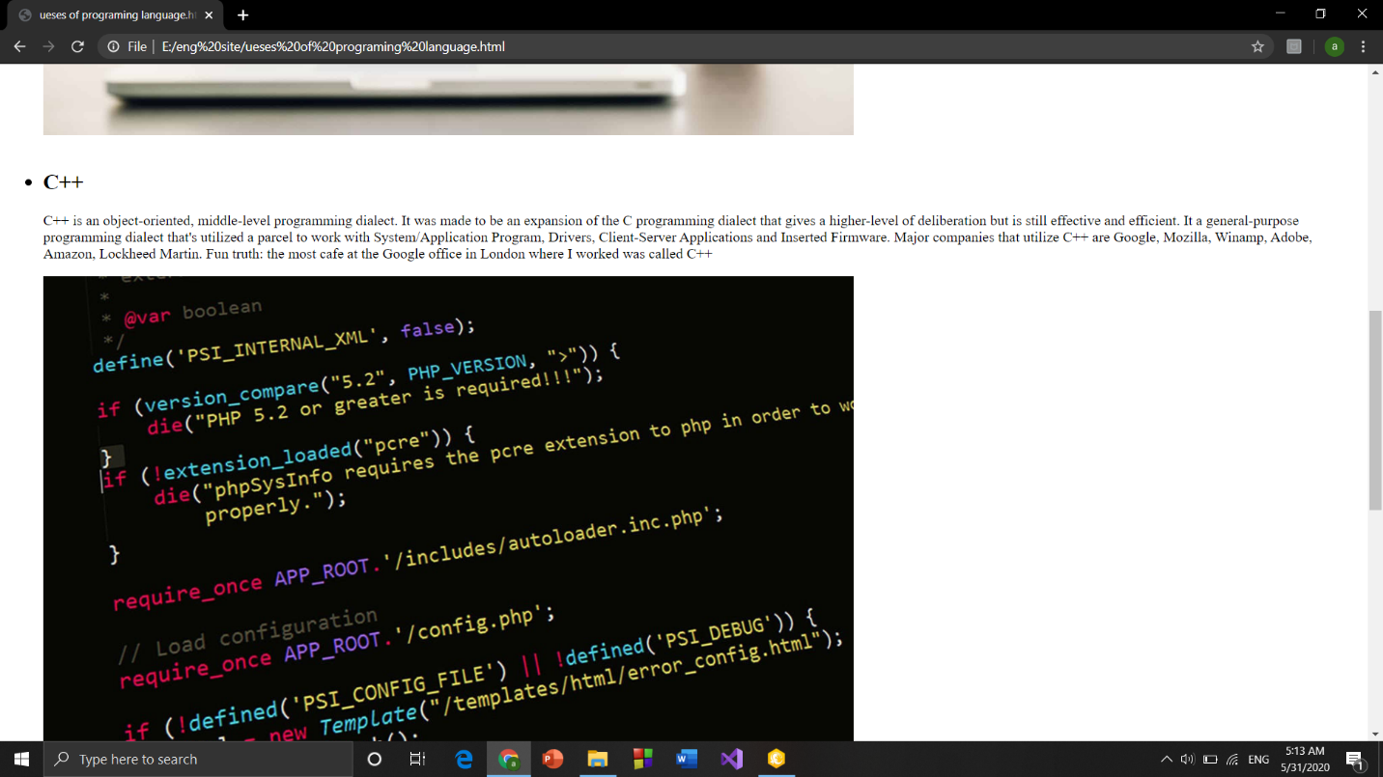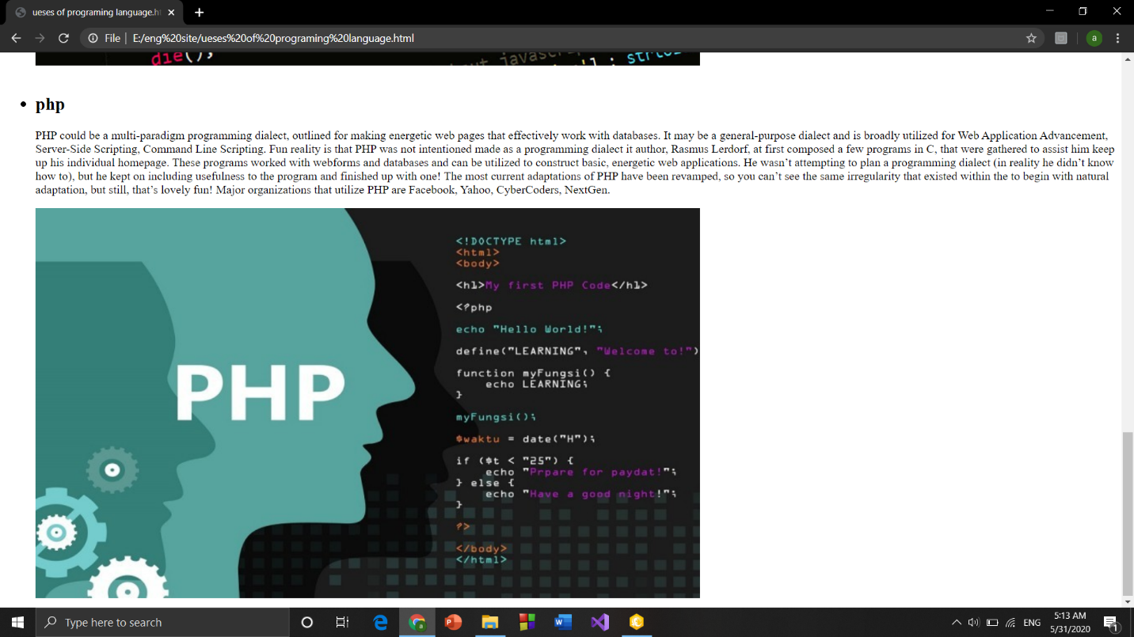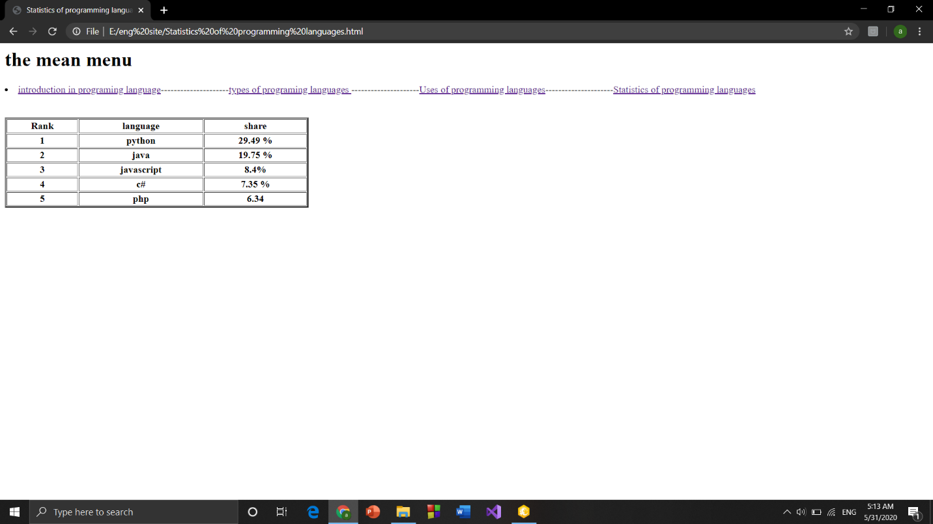

# References

<https://codingblonde.com/10-programming-languages-and-their-uses/>

<https://www.geeksforgeeks.org/introduction-to-programming-languages/>

<https://www.typesnuses.com/types-of-programming-languages-with-differences/>